

Employee Portal Management System
Report
Tunisie Télécom
Ilyass Chakroun
2025-2026

Thank You
I would like to express my sincere gratitude to all those who contributed to the successful completion of this project.
First and foremost, I extend my heartfelt thanks to my supervisor for their continuous guidance, valuable feedback, and encouragement throughout every stage of this work. Their support and expertise were instrumental in shaping the direction and quality of this project.
I would also like to thank my instructors and the teaching staff at ESPIN for providing the knowledge, resources, and motivation that made this project possible.
My deepest appreciation goes to my colleagues and classmates for their collaboration, constructive discussions, and constant support during the development process.
Finally, I would like to acknowledge my family and friends for their unwavering patience, encouragement, and belief in me. Their support has been my greatest source of strength and inspiration.
This project marks not only a technical achievement but also a valuable learning experience that I will carry forward into my future professional endeavors.

Table of Contents:
Table of Contents
Table of Contents: 1
Table of figures: 3
1. Thank You 1
2. Abstract 4
3. Introduction 4
3.1 Background 4
3.2 Project Overview 4
3.3 Technical Foundation 5
4. Objectives 5
4.1 Primary Goals: 5
Communication Enhancement: 5
Operational Efficiency: 5
Employee Engagement: 5
Security and Access Control: 6
5.Tools and Technologies 6
5.1 Development Stack: 6
5.2 Development Environment: 6
5.3 Additional Tools: 6
6. Database Design 7
6.1 Database Schema: 7
6.2 Core Tables: 7
employees Table: 7
coupons Table: 7
announcements Table: 7
feedback Table: 7
content Table: 8
Relationships: 8
6.3 Indexing Strategy: 8
7. User Interface 8
7.1 Design Principles: 8
8. employee interface 10
9. Admin interface 16
10. Conclusion 23
Key Takeaways: 23
Final Remarks: 23
Documentation and Resources: 23

Table of figures:
Figure 1 9
Figure 2 10
Figure 3 11
Figure 4 12
Figure 5 13
Figure 6 14
Figure 7 15
Figure 8 16
Figure 9 17
Figure 10 18
Figure 11 19
Figure 12 20
Figure 13 21
Figure 14 22

Abstract
This report presents the comprehensive design, development, and implementation of an Employee Portal Management System centralized web application designed to revolutionize employee engagement and organizational efficiency. The portal integrates essential employee-related functionalities including coupon management, company announcements, feedback mechanisms, and content distribution systems.

Built on modern web technologies, the system delivers an intuitive user interface for both administrators and employees, fostering seamless communication and streamlining operational workflows within the organization. This project demonstrates practical application of full-stack development principles while addressing real-world business requirements.

Introduction

3.1 Background
In today's fast-paced corporate environment, effective internal communication and employee engagement are critical success factors for any organization. Traditional methods of managing employee interactions—paper-based systems, scattered email communications, and disparate platforms—often lead to inefficiencies, miscommunication, and reduced employee satisfaction.

3.2 Project Overview
The Employee Portal Management System was developed as a comprehensive solution to address these challenges. This unified digital platform empowers employees with centralized access to:
- Company Announcements: Real-time updates on organizational news and events
- Coupon Management: Digital redemption system for employee benefits and rewards
- Feedback System: Interactive channels for employee voice and engagement
- Content Repository: Centralized access to internal documents and resources

3.3 Technical Foundation
The project leverages a modern web technology stack including PHP, MySQL, HTML5, CSS3, and JavaScript, ensuring scalability, maintainability, and cross-platform compatibility. The implementation follows industry best practices for web application development and database design.

Objectives

4.1 Primary Goals:
The system was designed with the following strategic objectives:

Communication Enhancement:
- Facilitate real-time, organization-wide communication
- Reduce information silos and improve transparency
- Enable targeted announcements to specific employee groups

Operational Efficiency:
- Streamline coupon distribution and redemption processes
- Automate content management workflows
- Reduce administrative overhead through digital automation

Employee Engagement:
- Provide interactive feedback mechanisms
- Empower employees with self-service capabilities
- Create a centralized hub for all employee-related activities

Security and Access Control:
- Implement robust user authentication systems
- Ensure role-based access to sensitive information
- Maintain data integrity and privacy compliance

5.Tools and Technologies

5.1 Development Stack:
Layer | Technology | Version | Purpose
Frontend | HTML5 | Latest | Semantic markup and structure
Frontend | CSS3 | Latest | Styling and responsive design
Frontend | JavaScript | ES6+ | Client-side interactivity
Backend | PHP | 7.4+ | Server-side processing
Database | MySQL | 8.0+ | Data persistence
Server | Apache | 2.4+ | Web server (via XAMPP)

5.2 Development Environment:
- IDE: Visual Studio Code with extensions for PHP, MySQL, and web development
- Version Control: Git for source code management
- Local Server: XAMPP (Cross-Platform Apache, MySQL, PHP, Perl)
- Operating Systems: Compatible with Linux and Windows environments
- Browser Testing: Chrome, Firefox, Safari, Edge

5.3 Additional Tools:
- Database Management: phpMyAdmin for database administration
- API Testing: Postman for backend endpoint validation
- Design: Figma/Adobe XD for UI/UX prototyping (if applicable)

Database Design

6.1 Database Schema:
The database architecture was meticulously designed to ensure relational integrity, scalability, and optimal performance. The schema follows Third Normal Form (3NF) principles to eliminate data redundancy.

6.2 Core Tables:

employees Table:
- Primary Key: employee_id (INT, AUTO_INCREMENT)
- Fields: first_name, last_name, email, password_hash, department, role, created_at, updated_at
- Purpose: Central repository for employee credentials and profile information

coupons Table:
- Primary Key: coupon_id (INT, AUTO_INCREMENT)
- Foreign Key: employee_id (references employees)
- Fields: coupon_code, description, value, expiry_date, status, redemption_date
- Purpose: Manages employee benefit coupons and redemption tracking

announcements Table:
- Primary Key: announcement_id (INT, AUTO_INCREMENT)
- Foreign Key: created_by (references employees)
- Fields: title, content, priority, target_audience, publish_date, expiry_date
- Purpose: Stores organizational announcements and notifications

feedback Table:
- Primary Key: feedback_id (INT, AUTO_INCREMENT)
- Foreign Key: employee_id (references employees)
- Fields: category, subject, message, status, response, submitted_at, responded_at
- Purpose: Captures employee feedback and tracks resolution

content Table:
- Primary Key: content_id (INT, AUTO_INCREMENT)
- Foreign Key: uploaded_by (references employees)
- Fields: title, description, file_path, file_type, category, access_level, upload_date
- Purpose: Manages internal documents and resources

Relationships:
- One-to-Many: One employee can have multiple coupons, feedback entries, and content uploads
- Referential Integrity: Foreign key constraints ensure data consistency
- Cascading Rules: Configured for appropriate delete/update behaviors

6.3 Indexing Strategy:
Strategic indexes were created on frequently queried columns to optimize performance:
- Email addresses for authentication lookups
- Employee IDs for relational queries
- Date fields for temporal filtering

User Interface

7.1 Design Principles:
The user interface was designed with the following principles:
- Simplicity: Clean, uncluttered layouts
- Consistency: Uniform design patterns across all pages
login:
emp@gmail.com /12356
admin@gmail.com /123456
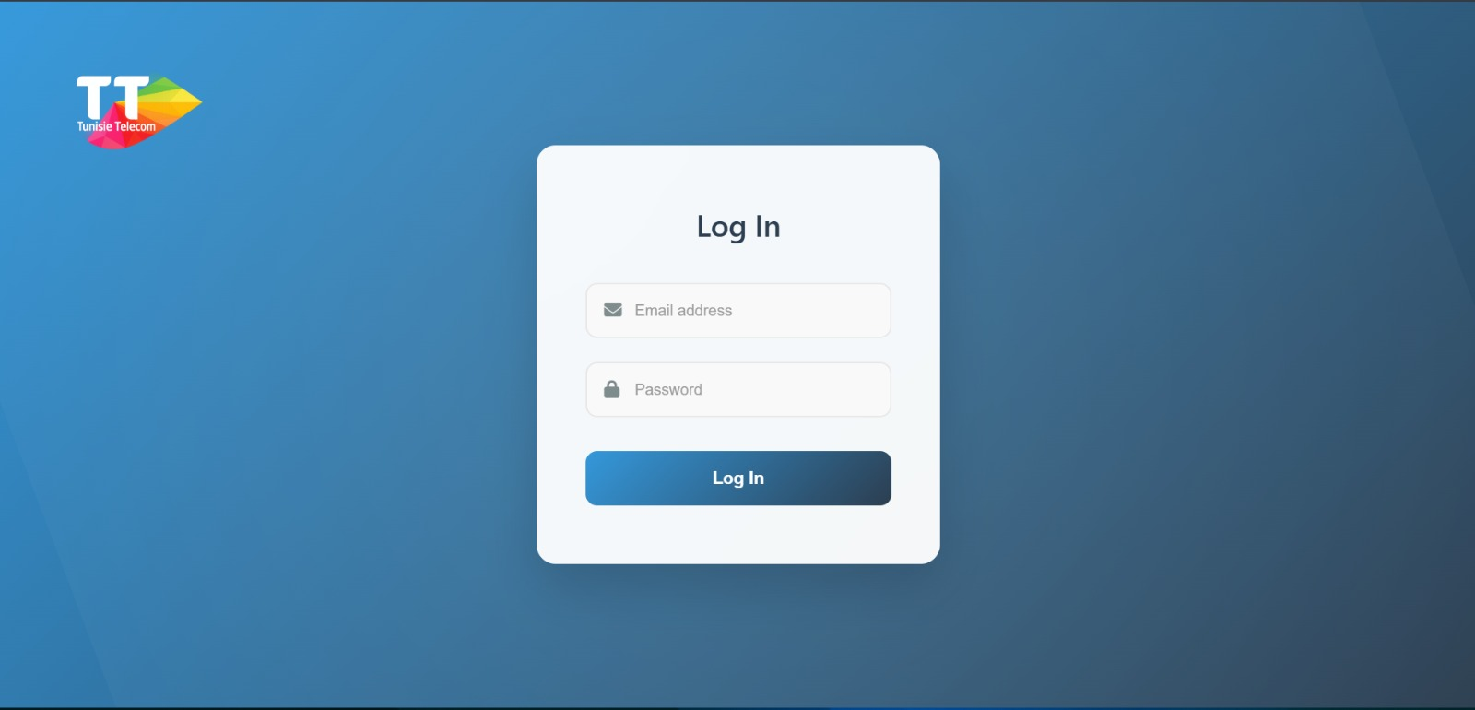
Figure 1

employee interface
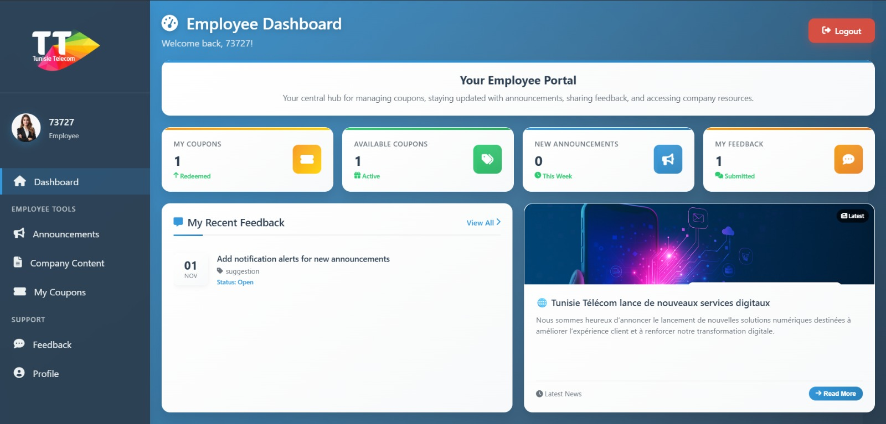
Figure 2
The Employee Dashboard serves as your one-stop command center: it instantly loads your personal stats—showing exactly how many coupons you’ve redeemed, how many are still active, new announcements posted this week, and total feedback you’ve submitted—each card clickable to jump straight to the related section. It pulls and displays your three most recent feedback tickets with date, subject, category, and real-time status (Open/Closed), plus lets you open the full list in one click. On the right, the latest published announcement appears as a rich card with image, title, and preview text, instantly clickable to read the full post. The glassy sidebar gives you single-click access to Announcements, Company Content, My Coupons, Feedback, and Profile pages, while the top-right Logout button securely ends your session. Everything updates in real-time from the database, animates smoothly, and works perfectly on mobile or desktop—no refreshes needed.

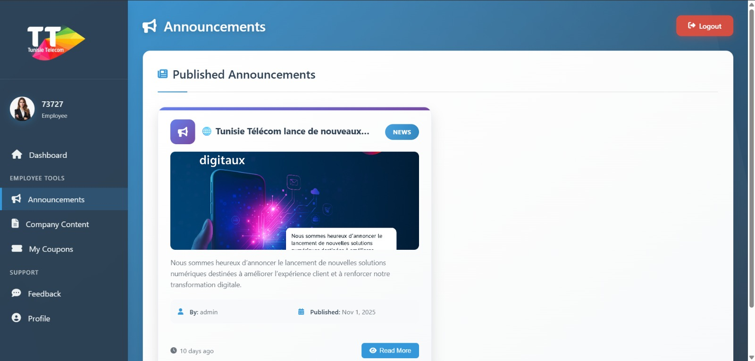
Figure 3
The Announcements page acts as your real-time news feed: it automatically pulls all published company updates from the database, sorting them by newest first in a flexible grid of cards—each featuring the title, optional preview image, brief description, author name (e.g., "ilyass chakroun"), exact publish date (e.g., Sep 24, 2025), and relative timestamp (like "34 days ago") for quick context. Tapping any card or the "Read More" button triggers an AJAX fetch to load full details into a sleek modal popup, showing expanded content, larger image if present, creator info, and formatted publish time, all without page reloads and with built-in error fallback to local data. The persistent glassy sidebar offers one-click jumps to Dashboard, Company Content, My Coupons, Feedback, and Profile, while the top-right Logout button confirms and securely terminates your session. Everything renders with fluid animations, hover effects, and perfect adaptability across mobile and desktop devices.
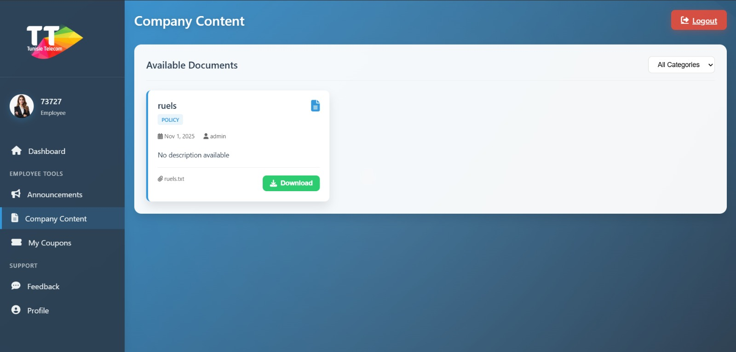
Figure 4
The Company Content page functions as your secure document library: it dynamically fetches all published company files from the database, organizing them into a responsive grid of cards sorted by creation date—each displaying the title (e.g., "pass"), category/type (e.g., FORM), file size (e.g., 228 Bytes), upload date (e.g., Sep 22, 2025), creator (e.g., "ilyass chakroun"), and a direct Download button that triggers instant file retrieval without page reloads. A top dropdown filter lets you sort by categories like "All Categories" to show/hide relevant cards, with an empty state message appearing if no matches exist. Clicking any card launches a detailed modal view showing expanded info including description, full metadata, and another Download option; the persistent glassy sidebar provides quick navigation to Dashboard, Announcements, My Coupons, Feedback, and Profile, while the Logout button prompts confirmation before ending your session—all with smooth animations, hover effects, and mobile-friendly design.
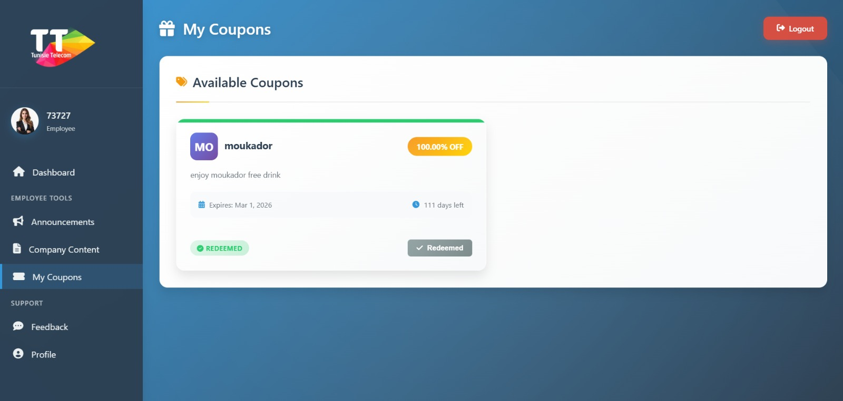
Figure 5
The My Coupons page operates as your personal rewards hub: it automatically queries the database for all active, non-expired coupons, displaying them in a clean grid of cards sorted by expiry date—each featuring the partner logo , discount value brief description expiry date (e.g., Nov 9, 2025), remaining days, and a status badge like "AVAILABLE"; if unredeemed, a "Redeem Now" button triggers an AJAX POST to instantly claim it, generating and revealing a unique code while updating the card to "Redeemed" without refreshing the page. Tapping any card opens a detailed modal popup with full info including the coupon code (visible post-redemption), description, terms, and another Redeem option if applicable; the ever-present glassy sidebar enables seamless navigation to Dashboard, Announcements, Company Content, Feedback, and Profile, with the Logout button requiring confirmation to end your session—all enhanced by fluid animations, hover pulses, and responsive design for any device.
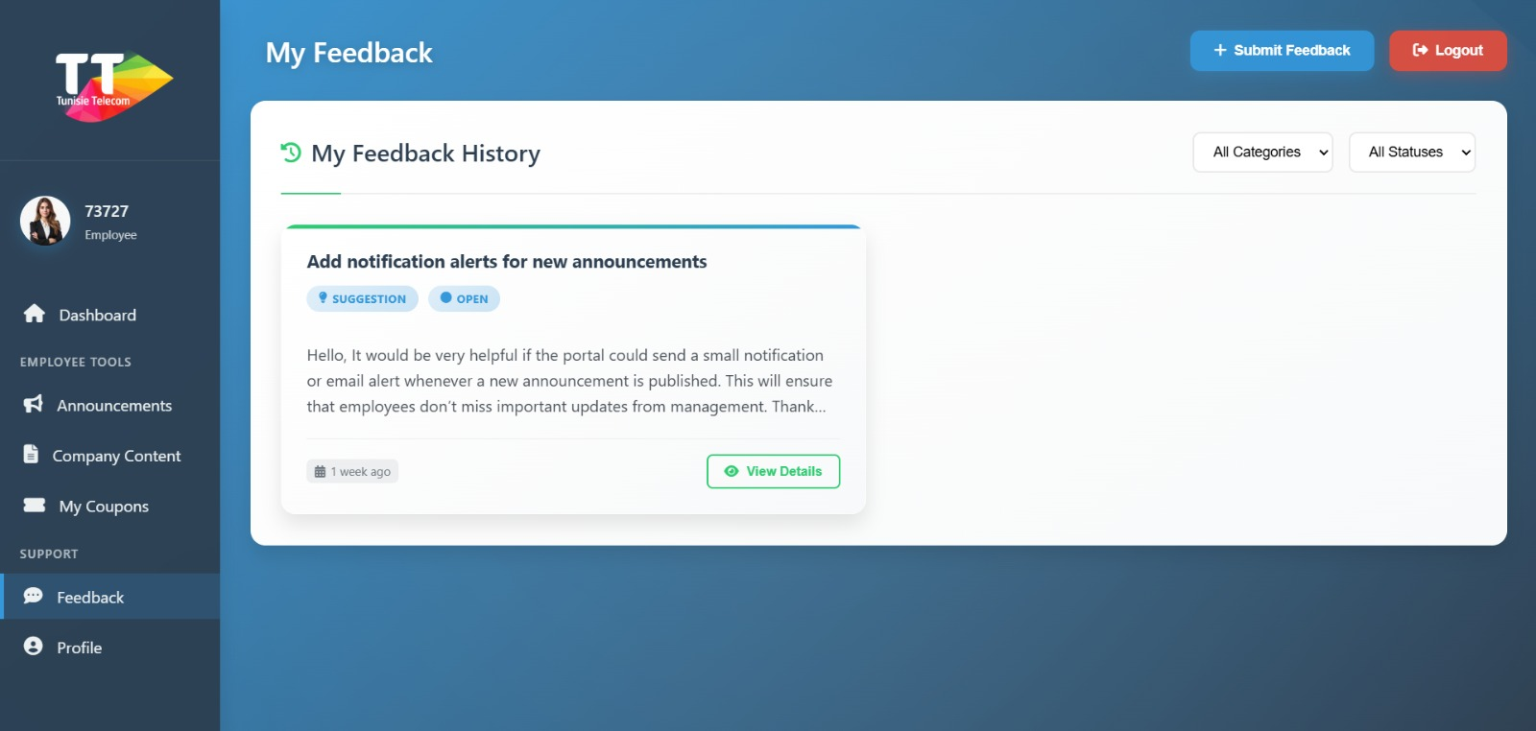
Figure 6
The My Feedback page serves as your interactive support center: it automatically fetches and displays all your submitted tickets from the database in a dynamic grid, each card showing the subject, color-coded category badge status indicator submission timestamp , and a "View Details" button that uses AJAX to populate a modal with the full message, metadata, and any admin responses in a threaded timeline—falling back to a "No responses yet" message if empty. Dual dropdown filters for categories and statuses instantly refresh the view without reloads; a blue "+ Submit Feedback" button launches a modal form for new submissions with subject input, category selector, message textarea, and AJAX-powered sending that validates fields and shows success notifications. The persistent glassy sidebar offers one-click navigation to Dashboard, Announcements, Company Content, My Coupons, and Profile, with the Logout button prompting confirmation all enhanced by fluid animations, hover effects, and full responsiveness across devices.
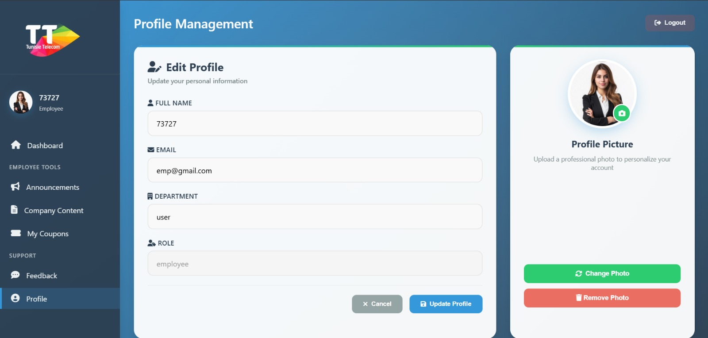
Figure 7
The Profile Management page is your personal settings hub: it pre-fills your details like full name (e.g., "ilyass"), email (e.g., "ilyasse@company.com"), department (e.g., "Administration"), and role (read-only as "employee") in an editable form.
Submit changes via AJAX for instant updates without refresh, with validation and success alerts.
Right-side photo uploader previews images before sending (JPG/PNG under 2MB), updates avatars site-wide on success.
"Remove Photo" button clears your picture via AJAX, resetting to initial-based default.
Glass sidebar enables quick navigation to Dashboard, Feedback, Coupons, and more.
Logout prompts confirmation for secure sign-out.
Smooth animations, hover effects, and responsive layout ensure seamless use on any device.

Admin interface
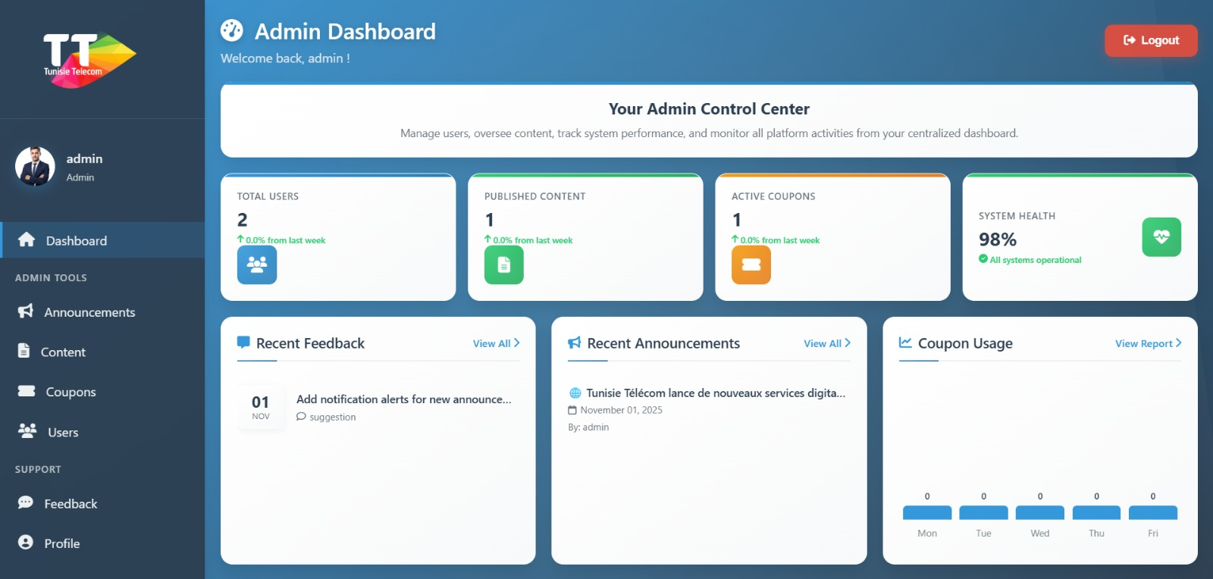
Figure 8
The Admin Dashboard delivers real-time platform oversight with key metrics: Total Users, Published Content, Active Coupons, and 98% System Health, each showing weekly trends.
Recent Feedback previews the latest employee tickets with category badges and dates.
Recent Announcements highlights newest posts with titles, authors, and timestamps.
Coupon Usage renders a live mini bar chart tracking daily redemptions across the week.
One-click admin tools in the glass sidebar: Announcements, Content, Coupons, Users, Feedback, Profile.
"View All" and "View Report" links jump to detailed sections instantly.
Logout requires confirmation for secure session termination.
Smooth animations, hover effects, and fully responsive across all devices.
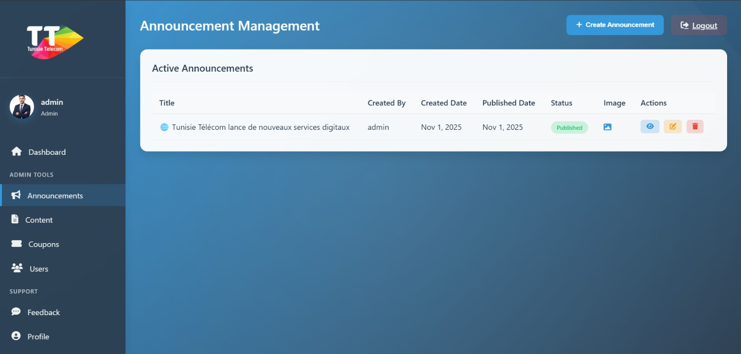
Figure 9
The Announcement Management page empowers admins to oversee company news: it lists all announcements in a sortable table with title, creator, dates, status (Published/Draft), image preview, and action icons for view, edit, delete.
"+ Create Announcement" opens a modal form for new posts with title, rich-text body, image upload (auto-preview), and publish toggle, saving via AJAX.
Edit icons load existing data into the same modal for updates, including image replacement.
View icons display full content in a clean popup with enlarged image if present.
Delete requires confirmation and removes entries instantly without refresh. Glass sidebar links to Dashboard, Content, Coupons, Users, Feedback, Profile. Logout prompts secure confirmation.
Fluid animations, hover effects, and responsive design for all devices.
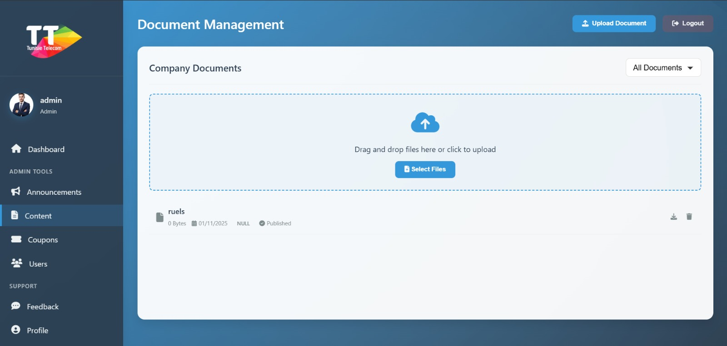
Figure 10
The Document Management page streamlines admin content handling: it features a drag-and-drop uploader with "Select Files" for easy additions, plus a "+ Upload Document" button opening a modal form with title, description, category selector, and publish toggle—saving via AJAX with progress bar and notifications.
Company Documents lists all files in a filterable grid (e.g., by All Documents), showing name (e.g., "ruels"), size (0 Bytes), upload date (01/11/2025), status (Published/NULL), and icons for download or delete with confirmation.Deletions and updates happen instantly without refresh, removing items from UI on success.
Dropdown filters dynamically hide/show documents by category.
Glass sidebar links to Dashboard, Announcements, Coupons, Users, Feedback, Profile.Logout prompts secure confirmation.
Error handling redirects on session expiry.
Smooth animations, hover effects, and responsive design for all devices.
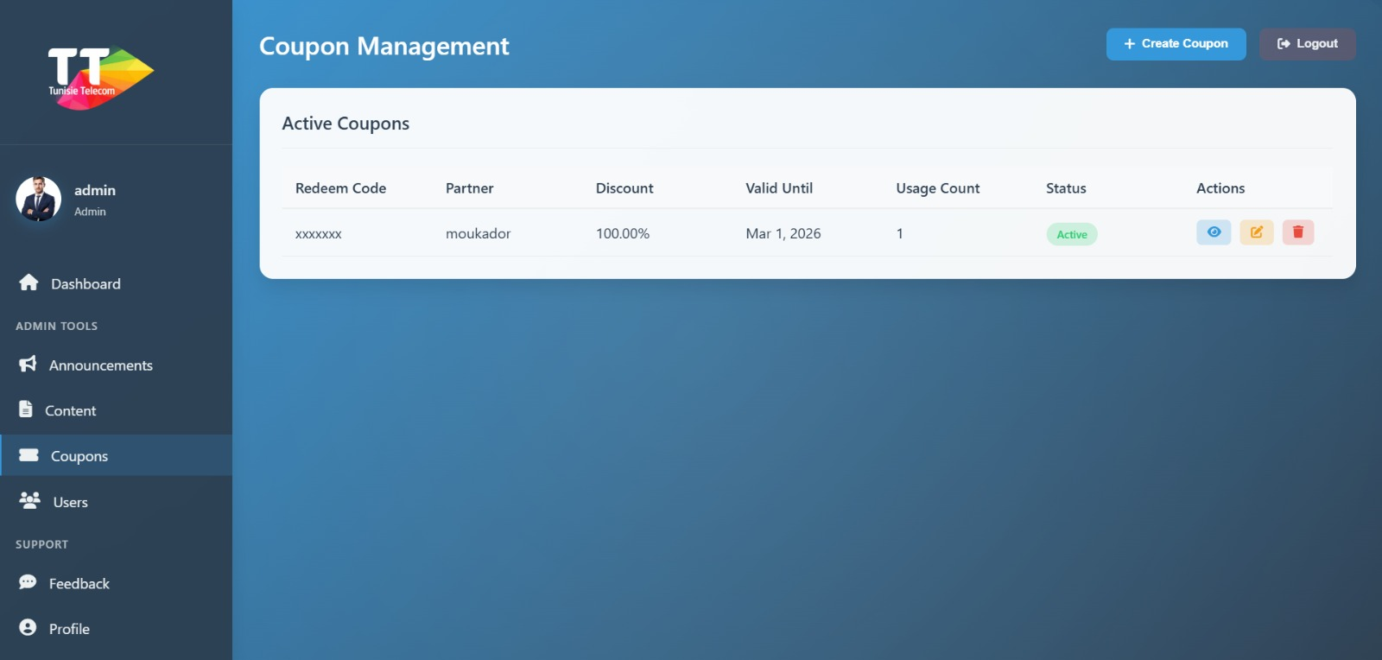
Figure 11
The Coupon Management page empowers admins to oversee rewards: it lists active coupons in a sortable table with redeem code, partner (e.g., moukador), discount (100.00%), expiry (Mar 1, 2026), usage count, status (Active), and icons for view, edit, delete.
"+ Create Coupon" launches a modal form with partner input, discount value/type selector, expiry date picker, redeem code, description text area, and terms—saving via AJAX with notifications.
Edit buttons populate the modal with existing data for quick updates.
View icons open a detailed popup showing full coupon info and redemption history.
Delete icons prompt confirmation and remove entries instantly without refresh.
Glass sidebar provides one-click access to Dashboard, Announcements, Content, Users, Feedback, Profile.
Logout requires confirmation for secure session end.
Fluid animations, hover effects, and responsive layout across devices.
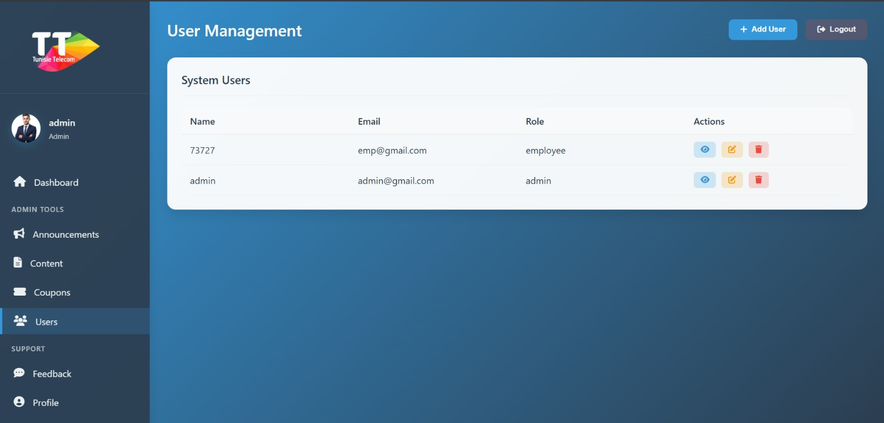
Figure 12
The User Management page enables admins to oversee accounts: it displays all system users in a sortable table with name, email, role, and action icons for view, edit, delete.
"+ Add User" opens a modal form for new accounts with name, email, password, role selector (admin/employee), and department.
Edit icons load user data into the modal for updates, including password reset.
View icons pop up a detailed modal showing full profile info like join date and last login.
Delete icons prompt confirmation and remove users via AJAX without refresh.
Glass sidebar links to Dashboard, Announcements, Content, Coupons, Feedback, Profile.
Logout requires confirmation for secure exit.
Smooth animations, hover effects, and responsive design across devices.
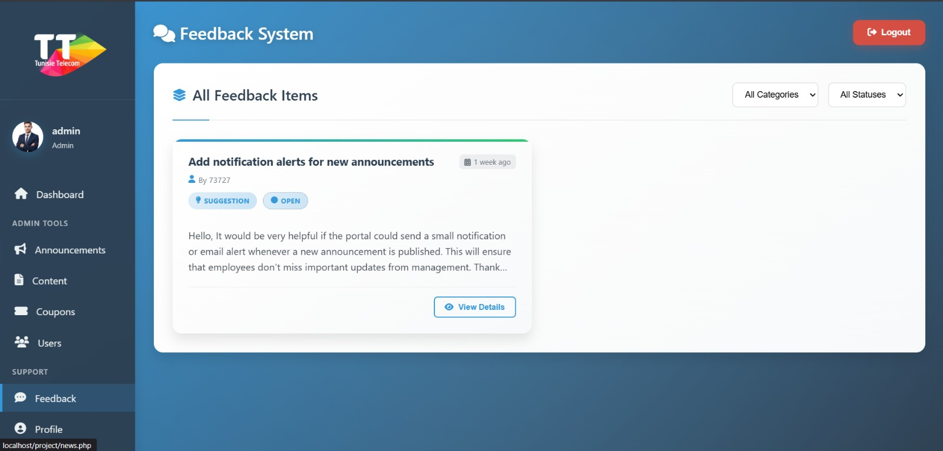
Figure 13
The Feedback System page serves as admin's ticket oversight tool: it loads all employee submissions into filterable cards, showing subject, submitter (e.g., by 73727), category (Suggestion), status (Open), relative date (1 week ago), and preview text.
Dual dropdowns for categories (All/Complaint/Suggestion) and statuses (All/Open/Closed) refresh the grid instantly without reloads.
"View Details" launches an AJAX modal with full message, metadata, threaded responses, and a form to add new replies that post via JSON without refresh.
Replies update the modal and list in real-time upon success.
Empty states show friendly messages if no feedback matches filters.
Glass sidebar offers one-click navigation to Dashboard, Announcements, Content, Coupons, Users, Profile.
Logout button prompts confirmation for secure session end.
Enhanced by smooth animations, hover effects, and responsive design across devices.
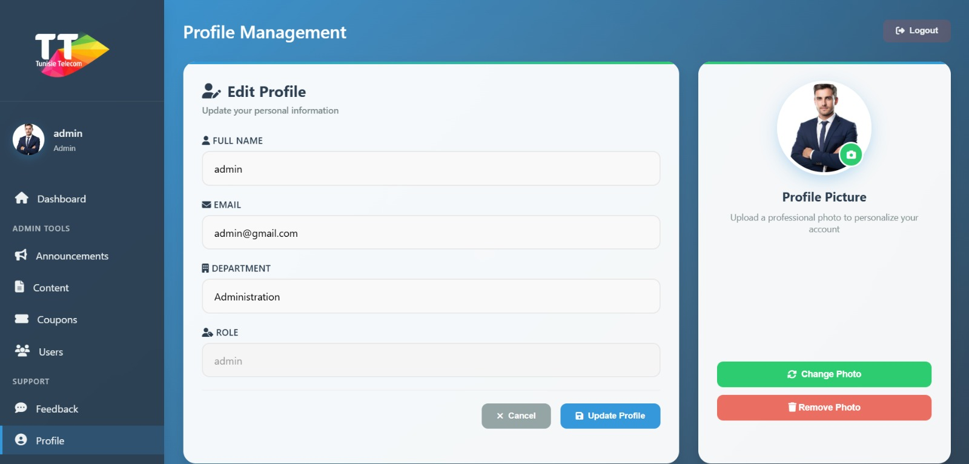
Figure 14
The Profile Management page serves as your admin settings center: it auto-populates details like full name (e.g., "admin"), email (e.g., "admin@gmail.com"), department (e.g., "Administration"), and read-only role ("admin") in an editable form.
Submit updates via AJAX for real-time saves without reloads, including validation and alerts.
Right-side uploader previews photos (JPG/PNG <2MB) before upload, instantly refreshing avatars across the site.
"Remove Photo" clears images via AJAX, falling back to name-initial default.
Glass sidebar under "ADMIN TOOLS" offers quick links to Announcements, Content, Coupons, Users, Feedback.
Logout button confirms before secure session termination.
All with fluid animations, hover effects, and mobile-responsive design.

Conclusion
The Employee Portal Management System represents a successful implementation of modern web development principles applied to solve real-world organizational challenges. The project demonstrates proficiency in full-stack development, database design, security implementation, and user experience design.

Key Takeaways:
- Technical Excellence: The system showcases robust architecture, clean code practices, and adherence to industry standards for web application development.
- Practical Impact: By consolidating disparate employee management functions into a unified platform, the system delivers tangible improvements in communication efficiency and operational productivity.
- Scalable Foundation: The modular design and well-structured codebase provide a solid foundation for future enhancements and feature additions.
- Learning Outcomes: This project provided invaluable hands-on experience in database design, backend logic implementation, frontend development, security best practices, and system testing methodologies.

Final Remarks:
The successful completion of this project validates the effectiveness of the chosen technology stack and architectural approach. The Employee Portal Management System stands as a testament to the power of thoughtful design, careful implementation, and user-centered development. It fulfills all initial objectives while establishing a framework for continued innovation and improvement.
This system is production-ready and can be deployed in real-world organizational environments with minimal additional configuration, providing immediate value to any company seeking to modernize their employee engagement infrastructure.

Documentation and Resources:
- PHP Official Documentation
https://www.php.net/docs.php
Comprehensive reference for PHP language features and functions
- MySQL Documentation
https://dev.mysql.com/doc/
Database design, query optimization, and best practices
- W3Schools Web Technologies
https://www.w3schools.com
HTML5, CSS3, and JavaScript tutorials and references
- Apache Friends (XAMPP)
https://www.apachefriends.org
Local development server environment documentation

